Name: Om Rajale
AIEC 2
Roll 26
Batch A

Experiment – 07
Building an Azure Machine Learning Model for an IoT Edge Module
Objective: Learn how to collect IoT sensor data, prepare a dataset, train a Machine Learning model in Azure ML, register the trained model, and prepare it for deployment to an IoT Edge module.

1. Overview & Architecture Workflow
In this lab, we will train a Decision Tree Classifier using simulated IoT sensor data (Temperature and Humidity) to predict device status (Normal vs. High).

Workflow Diagram
[ IoT Sensor Data ]
│ (Temperature & Humidity)
▼
[ Azure ML Dataset ]
│
▼
[ Azure ML Compute Job ]
│ (Runs train_model.py)
▼
[ Decision Tree Classifier ]
│
▼
[ Trained Model (.pkl) ]
│
▼
[ Azure ML Model Registry ]
│
▼
( Next Step: IoT Edge Deployment )

Step 1 — Open Azure Machine Learning Studio
- Navigate to Azure Machine Learning Studio.
- Sign in using your Azure credentials.
- Select your designated workspace

Step 2 — Create an Azure ML Workspace
If a workspace does not already exist, create one via the Azure Portal:
- Search for Machine Learning in the search bar.
- Click Create > Machine Learning.
- Configure the following properties:
Setting | Example Value
Subscription | Your Azure Subscription
Resource Group | IOTEdgelabRG
Workspace Name | aml-iot-lab
Region | Central India
- Click Review + Create Create. Once created, launch Azure ML Studio.

Step 3 — Create the Training Dataset
We will create a CSV file named iot_temperature_humidity.csv.

CSV Content
temperature,humidity,status
22,45,Normal
24,50,Normal
25,55,Normal
27,60,Normal
29,65,Normal
31,70,High
33,75,High
35,80,High
20,40,Normal
23,48,Normal
26,52,Normal
28,58,Normal
30,68,High
32,72,High
34,78,High
21,42,Normal
25,50,Normal
Dataset Structure
- temperature: Input feature (IoT telemetry variable 1)
- humidity: Input feature (IoT telemetry variable 2)
- status: Target label (Normal or High)

Step 4 — Create a Compute Instance
- In Azure ML Studio, click Compute from the left side menu.
- Under Compute instances, click New.
- Choose a low-cost virtual machine size (e.g., Standard_DS11_v2).
- Set the compute name to: iot-ml-compute.
- Click Create and wait until the state updates to Running.
- 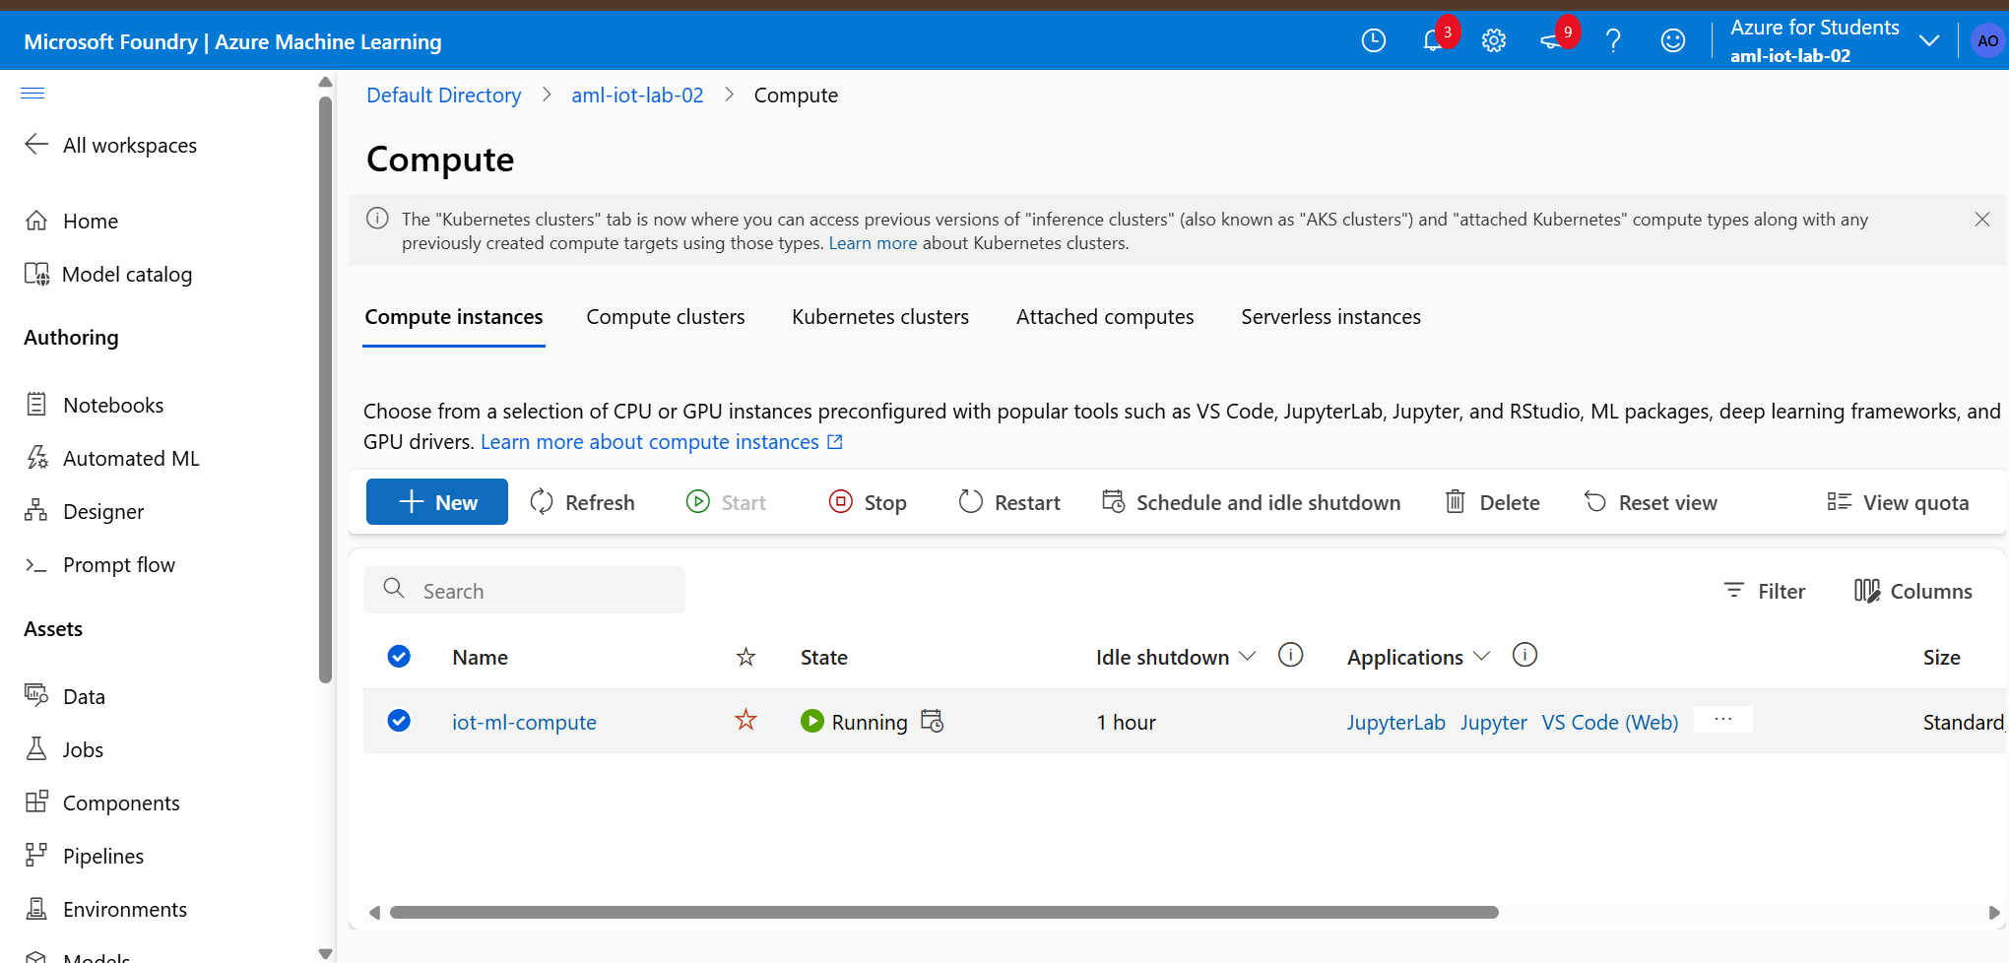

Step 5 — Upload Data Asset to Azure ML
- Go to Data Create Data asset.
- Select From local files.
- Upload iot_temperature_humidity.csv.
- Name the asset: iot-sensor-data.
- Set the type to Tabular and complete the wizard.
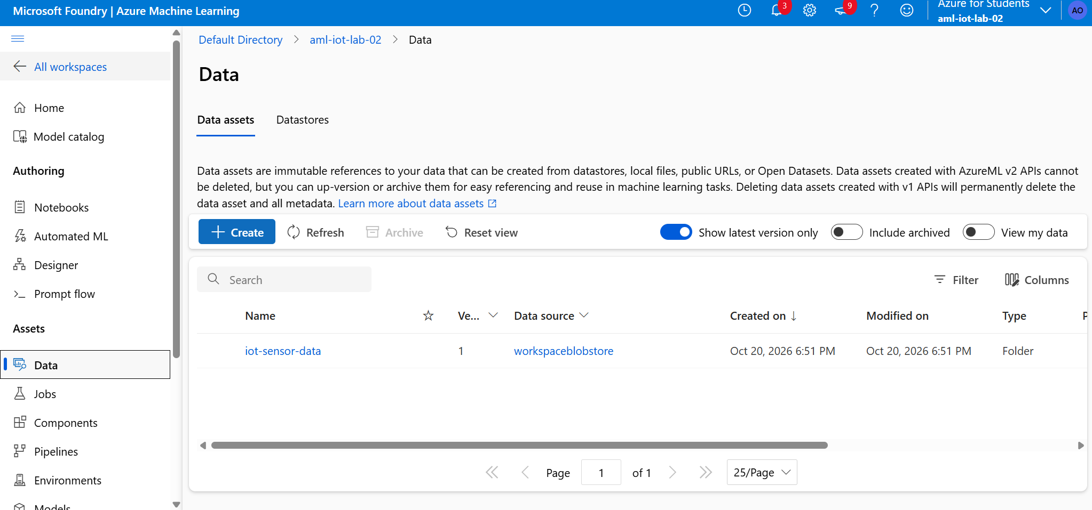

Step 6 — Create the Python Training Script (train_model.py)
Create a script titled train_model.py:
import pandas as pd
import joblib
from sklearn.model_selection import train_test_split
from sklearn.tree import DecisionTreeClassifier
from sklearn.metrics import accuracy_score
# 1. Load dataset
data = pd.read_csv("iot_temperature_humidity.csv")
# 2. Define input features (X) and target label (y)
X = data[["temperature", "humidity"]]
y = data["status"]
# 3. Train/Test split
X_train, X_test, y_train, y_test = train_test_split(
X,
y,
test_size=0.2,
random_state=42
)
# 4. Initialize and train the Decision Tree Classifier
model = DecisionTreeClassifier(random_state=42)
model.fit(X_train, y_train)
# 5. Model evaluation
y_pred = model.predict(X_test)
accuracy = accuracy_score(y_test, y_pred)
print(f"Model Accuracy: {accuracy:.2f}")
# 6. Export the serialized model file
joblib.dump(model, "iot_temperature_model.pkl")
print("Model saved successfully as iot_temperature_model.pkl")
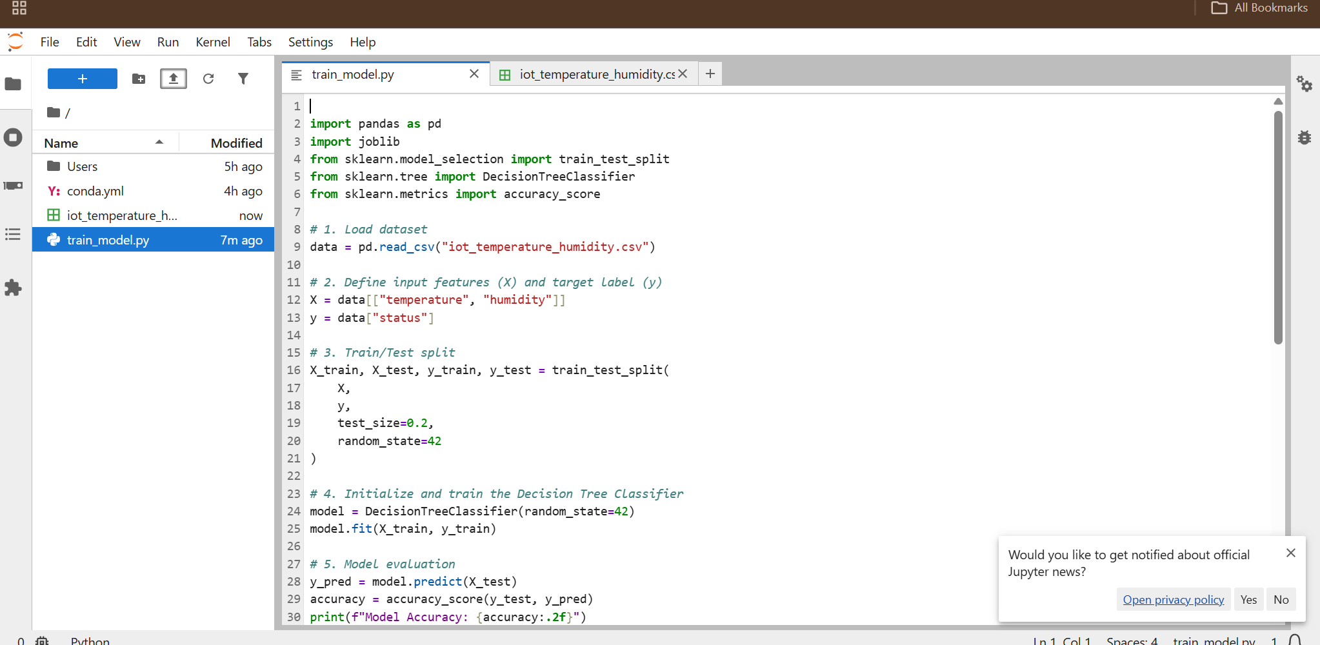

Step 7 — Define the Environment (conda.yml)
Create a configuration file named conda.yml to specify runtime dependencies:
name: iot-ml-environment
channels:
- conda-forge
dependencies:
- python=3.10
- pip
- pip:
- pandas
- scikit-learn
- joblib
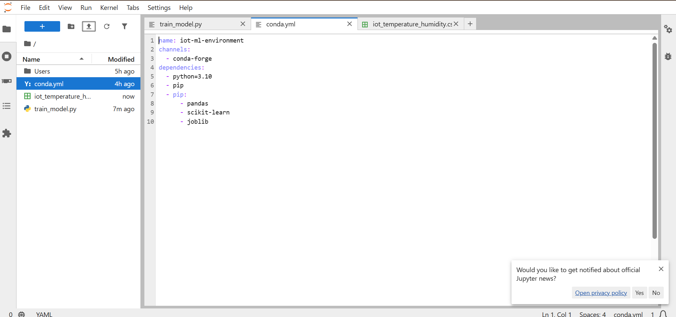

Step 8 — Submit and Run the Training Job
- In Azure ML Studio, go to Jobs Create job.
- Select ML Job.
- Set the execution command:
python train_model.py
- Attach train_model.py and iot_temperature_humidity.csv.
- Target Compute: iot-ml-compute.
- Set the Environment using conda.yml.
- Click Submit.
- 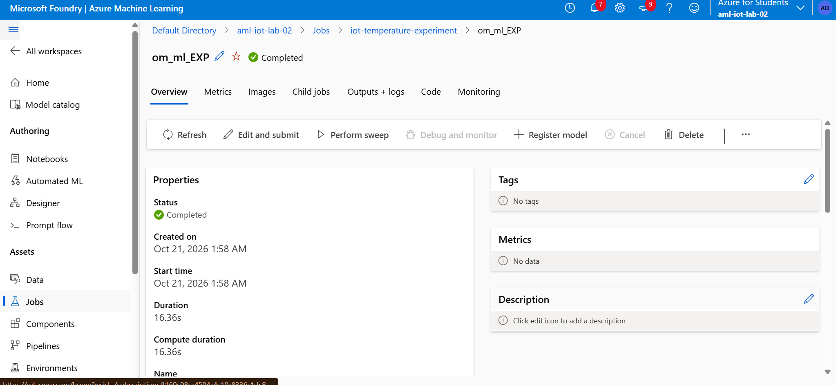

Step 9 — Evaluate Model Execution & Accuracy
- Open the completed Job in Azure ML Studio.
- Select Outputs + logs and review the execution logs (std_log.txt).
- Verify output:
Model Accuracy: 0.75
Model saved successfully as iot_temperature_model.pkl
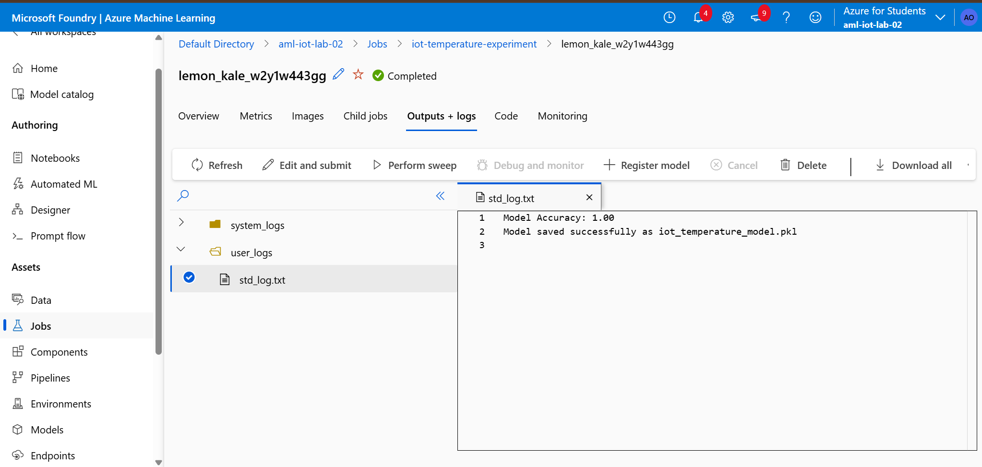

Step 10 — Register Model in Registry
- Navigate to Models Register From local files.
- Upload iot_temperature_model.pkl.
- Set Name: iot-temperature-model.
- Set Version: 1.
- Click Register.

Step 11 — Verify the Registered Model
Go to:
Models
iot-temperature-model
with a version such as: 1
This is the trained ML model that we can use for the next practical.
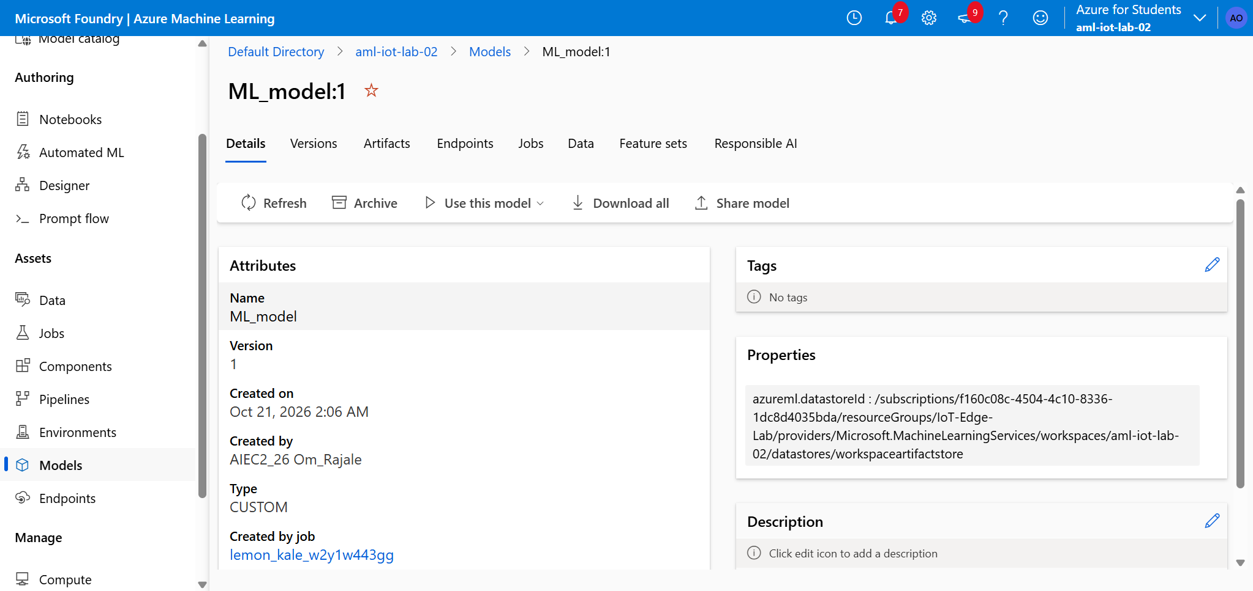

Step 12 — Model Inference Logic (Sample Tests)
Scenario | Input (Temperature, Humidity) | Expected Model Prediction
Case 1 | , | High
Case 2 | , | Normal

Summary Checklist
- Created Azure ML Workspace & Compute Instance
- Prepared IoT Telemetry CSV Data Asset
- Written train_model.py and environment definition (conda.yml)
- Executed Azure ML Job and verified accuracy
- Registered iot-temperature-model:1 for IoT Edge container deployment

